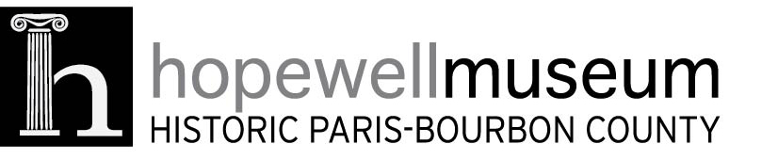

Thank you for your membership. As part of your sponsorship your company receives 2 tickets to our our annual Derby Party on April 25 at Mustard Seed Hill from 7-11 PM. We do not issue a ticket for this event, but if you would like to take advantage of this membership benefit please email info@hopewellmuseum.org to make your reservation. We hope that you can attend!

Thank you,

Cheryl Caskey
Executive Director

